**Number system:**

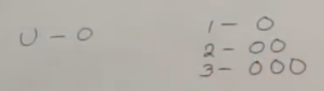

* This is unary number system

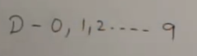

* This is decimal number system
* Next one is binary number system, in this base number is 0. If binary number is n then it will be as below



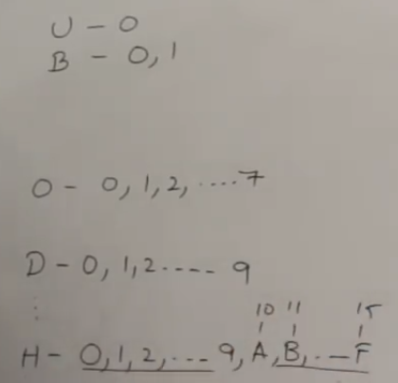

* In octa decimal, we have 8 numbers and in hexa, we have 16 numbers. 0 to 9 and A to F. A represents 10 and F represents 15

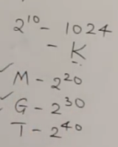

**Dividing the bits:**

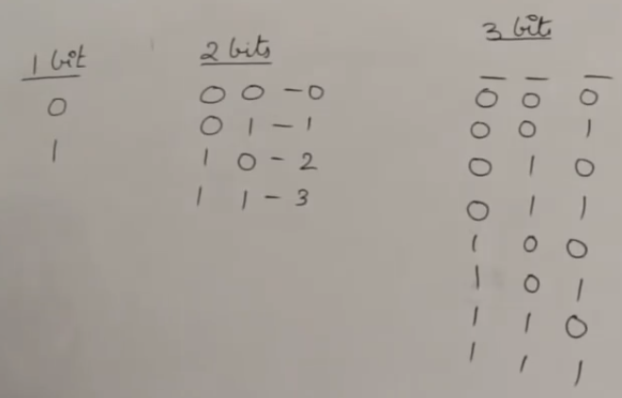

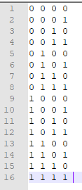

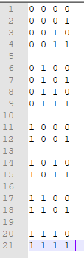

* This we can divide into parts. If we select two parts, we can divide one part with 0 and another with 1

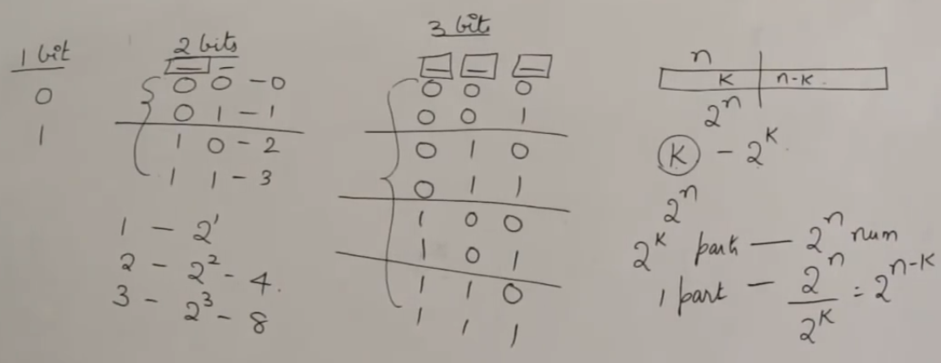

**Difference between bit, byte and speed, data:**

* Bit is the smallest information computer can understand. It is either 0 or 1
* 8 bits forms a byte

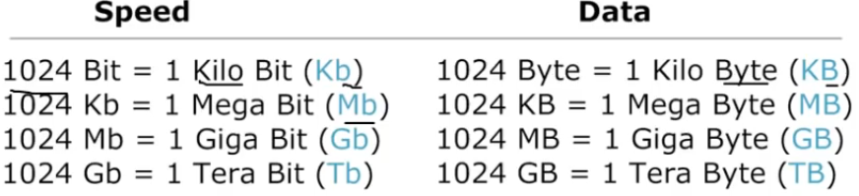

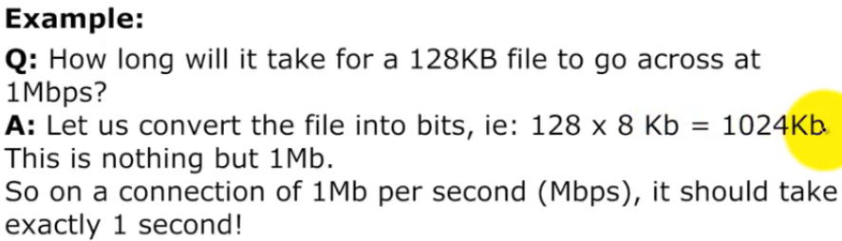

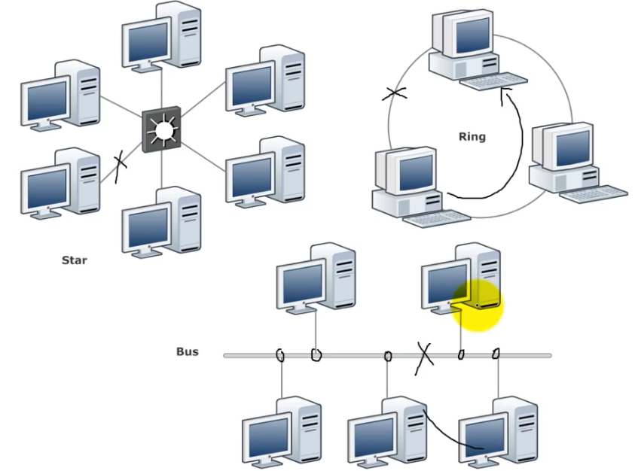

* In today’s world, we use hybrid networking which may be either of start or bus or ring or all of them